**Project team 24 - <Disaster Report System>**

*Team Members:*

Anil Sadasivuni

Chaitanya Deshpande

Rithesh Shetty

Sharath Kumar Reddy Lenkala

## ***PROJECT PROPOSAL***

**Content**:

This database system keeps track of disasters, things affected by the disasters and post disaster recovery statistics.

**Scope:**

This database system allows user to understand the magnitude of particular disaster and its adverse effects on the environment, user can also track the recovery of the individuals and infrastructure.

**Objective:**

1. To track Disaster name, Disaster type, Disaster affected area
2. To track Emergency evacuation details
3. To track general issues type occurred to the public during disaster(food, transport, power)
4. To track fatality and injured people due to disaster
5. To track affected person name and details of the person
6. To track affected infrastructure, property
7. To track services provided to the affected people during disaster
8. To track funding provided by various agencies during disaster
9. To track insurance claim by the people and effected industries
10. To track funds provided by government and other agencies for recovery

# **Project: Sprint 0 - Environment setup and high level requirements & conceptual design**

## ***PROJECT ENVIRONMENT***

For project development, we will be using 2 software’s namely JAVA and AWS(RDS) + MySQL. We will be using Java to build the frontend i.e. user interface of the application and for the data storage and manipulation purposes we will be using AWS (RDS) + MySQL.

## ***HIGH LEVEL REQUIREMENTS***

### **Initial user roles**

|  |  |
| --- | --- |
| **User Role** | **Description** |
| Database Administrator | Database administrator have privileges like insert, update and delete data |
| Special Privilege User | Users who are given privileges on demand to view any kind of information in the database like President of America |
| Reporter | User with privileges to view and report any kind of information from disaster report system |
| Insurance Analyst | User who have the privileges to view insurance claims information in the database system |
| Medical Analyst | User who have the privileges to view the medical information of the effected people in the database |
| Funding Administrator | Government appointed funding administrator who tracks the funding during or after the disaster |

### **Initial user story descriptions**

|  |  |
| --- | --- |
| **Story ID** | **Story description** |
| US1 | As a Database Administrator, I want to access any kind of information in the database for inserting, updating or deleting the information |
| US2 | As a Special Privilege User, I want to have access to view any kind of information in the database so that I can analyze the disaster related information |
| US3 | As a Reporter, I should be able to present Emergency Service, adverse effects, Funding, Casualty and Insurance details of any disaster to the government on demand |
| US4 | As an Insurance analyst, I should be able to access details of any insurance related information of a disaster in the database |
| US5 | As a Medical analyst, I should be able to access details of any casualty related information of a disaster in the database |
| US6 | As a Funding administrator, I should be able to track and analyze funding related information of a disaster in the database |

## ***HIGH LEVEL CONCEPTUAL DESIGN***

Entities:

1. User

2. Role

3. Disaster

4. Emergency Service

5. Adverse effect

6. Funding

7. Casualty

8. Insurance

Relationships:

1. Disaster leading to Casualty

2. Disaster leading to adverse effect

3. Funding for Disaster

4. Emergency Service offered for adverse effect

5. Insurance claim for adverse effect

6. Insurance claim for Casualty

**Project: Sprint 1 - Database design and implementation**

## ***REQUIREMENTS***

User Stories in decreasing order of priority

|  |  |
| --- | --- |
| **Story ID** | **Story description** |
| US1 | As a Database Administrator I want to add role with read/write access of a user with privileges. |
| US2 | As a User i should be able to login and logout of the application so that i can use the application. |
| US3 | As a Database Administrator I want to add name, type, city, state, country, start date, start time, end date, end time and intensity details of a disaster so that end users can use the information on demand. |
| US4 | As a Database Administrator I want to add name, service provider and description of emergency services provided for a disaster, so that end user can use the information on demand. |
| US5 | As a Database Administrator I want to add name and prevention possibility of adverse effects caused by a disaster, so that end user can use the information on demand. |
| US6 | As a user with the role of ‘Emergency Service Provider’, I want to add name, service provider and description of emergency services provided for a disaster, so that emergency services provided are tracked. |
| US7 | As a user with the role of ‘Adverse Effect Reporter’, I want to add name and prevention possibility of adverse effects caused by a disaster, so that end user can use the information on demand. |
| US8 | As a reporter I should be able to give name of a disaster as input and view details of that disaster so that I can report it to the government/authorities. |
| US9 | As a reporter I should be able to give city,state and country as input and view details of the disaster affecting that place so that I can report it to the government/authorities. |
| US10 | As a reporter I should be able to enter name of disaster and view details of emergency services provided for that disaster, so that I can report to the government/authorities. |
| US11 | As a reporter I should be able to enter name of disaster and view adverse effects of that disaster, so that I can report to the government/authorities. |
| US12 | As a Database Administrator I want to update insurance claimed so that reporter can use the information. |
| US13 | As a Database Administrator I want to update casualty caused during disaster so that reporter can use the information |
| US14 | As a Database Administrator I want to update the funding for the disaster, so that reporter can use the information |
| US15 | As a reporter I want to view insurance claimed, so that I can report to the government/authorities. |
| US16 | As a reporter I want to view casualty due to disaster, so that I can report to the government/authorities. |
| US17 | As a reporter I want to view funding for disaster, so that I can report to the government/authorities. |
| US18 | As a Insurance Analyst i want to update claimed insurance details so that reporter can use the information. |
| US19 | As a Medical Analyst I want to update the medical services provides during disaster, so that reporter can report to the government |
| US20 | As a Funding Analyst i want to update details of funding for disaster so that reporter can use the information. |

## ***CONCEPTUAL DESIGN***

Entity: **Disaster**

Attributes:

name

type

place [composite]

city,

state,

country

start_date

start_time

intensity

end_date

end_time

Primary key Justification: Every disaster will have a unique name. so combination of disaster name and place can uniquely identify each and every disaster in the system. Intensity will be defined with respect to disaster type on the respective scale like (Earthquake will be measured in Richter scale, Hurricane will be measured in Saffir-Simpson scale and Volcano will be measured in Volcanic Explosivity Index).

Entity: **EmergencyService**

Attributes:

name

services_provider

description

Primary key justification : Every service provided by a service provider will have a unique name. Combination of service_provider and name can uniquely identify emergency services in the system.

Entity: **AdverseEffect**

Attributes:

name

preventive

Primary key justification : From the name of adverse effect we can uniquely identify AdverseEffect.Preventive attribute will define whether the adverse effect was preventive (food outage, water outage) or non preventive (acid rain, landslide).

Entity: **User**

Attributes:

user_name

password

Primary key justification : Each user will have unique user_name, so from use_name we can uniquely identify the User.

Entity: **Role**

Attributes:

role_name

privilege

Primary key Justification : As every role will have a unique role_name, role_name can uniquely identify roles.

**Relationships:**

Relationship: **Disaster** leads to **AdverseEffect**

Cardinality:

Many to many

Participation:

**Disaster** has total participation

**AdversEffect** has partial participation

Note : Assuming every disaster has adverse effect.

Relationship: **EmergencyService** offered for **Disaster**

Cardinality:

Many to many

Participation:

**Disaster** has total participation

**EmergencyService** has partial participation

Note : Assuming every disaster requires emergency service.

Relationship: **User** has a **Role**

Cardinality:

Many to One

Participation:

**User** has total participation

**Role** has partial participation

Note : Every User will have only one role in the system.

## ***LOGICAL DESIGN***

Table: **Disaster**

Columns:

disaster_id

name

type_id[foreign key; references type_id of **DisasterType** table]

city

country

start_date

start_time

end_date

end_time

intensity

Justification : From the disaster_id we can uniquely identify the disaster. Foreign Key approach has been followed here as each disaster_id is related to only one type_id of DisasterType.

Table: **DisasterType**

Columns:

type_id

disaster_type

Justification : We created separate table for disaster type. We are covering 5 types of disasters which are Earthquake, Tsunami, Volcano, Nuclear-Explosion and Hurricane.

Table: **EmergencyService**

Columns:

emg_svr_id

name

service_provider

description

Justification : From emg_svr_id we can uniquely identify the emergency service.

Table : **AdverseEffect**

Columns:

adverse_id

name

preventive

Justification: From adverse_id we can uniquely identify the adverse effect.

Table: **Role**

Columns:

role_id

role_name

privilege

Table: **User**

Columns:

user_name

password

role_id [foreign key; references **role_id** of **Role** table]

Justification : As each user will have specific role_id of role table, foreign key approach has been followed.

Table : **DisAdvEff**

Columns:

disaster_id [foreign key; references disaster_id of **Disaster** table]

adverse_id [foreign key; references adverse_id of **AdverseEffect** table]

Justification : As a disaster_id can be linked to multiple adverse_id and a adverse_id can be linked to multiple disaster_id, cross reference approach has been followed to establish relationship.

Table : **DisEmgSvr**

Columns:

disaster_id [foreign key; references disaster_id of **Disaster** table]

emg_svr_id [foreign key; references emg_svr_id of **EmergencyService** table]

pre_post_type

Justification : As a disaster_id can be linked to multiple emg_svr_id and a emg_svr_id can be linked to multiple disaster_id, cross reference approach has been followed to establish relationship.

Query and Screenshots:

Query 1:

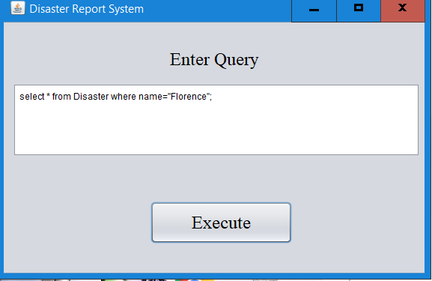

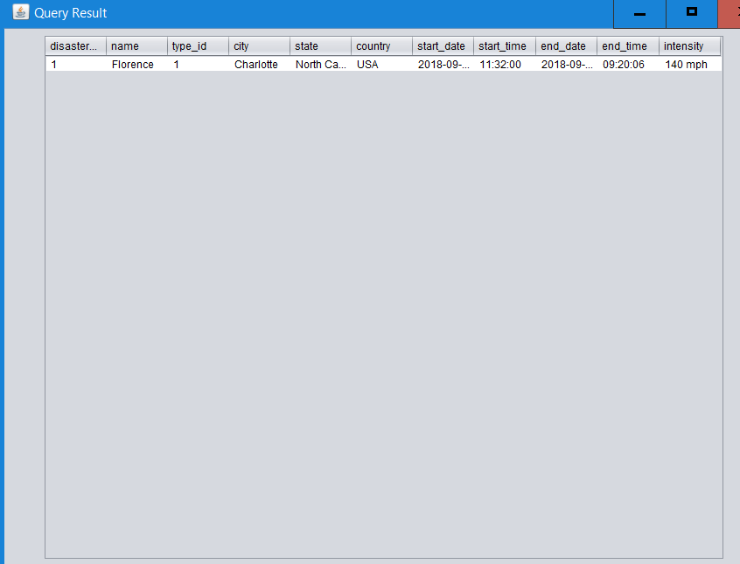

Query 2:

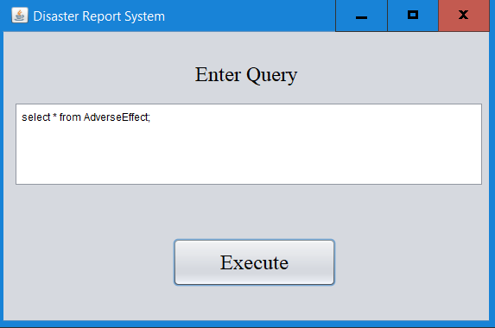

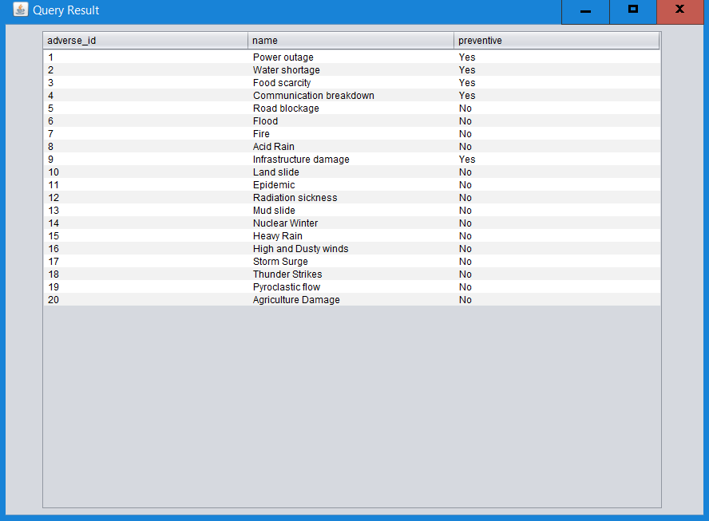

Query 3:

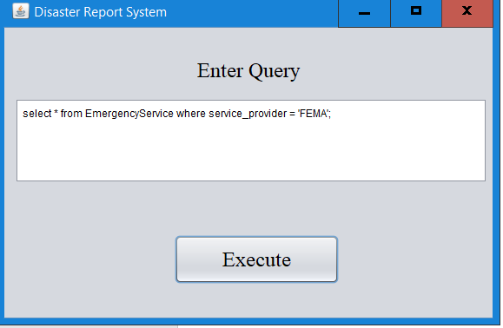

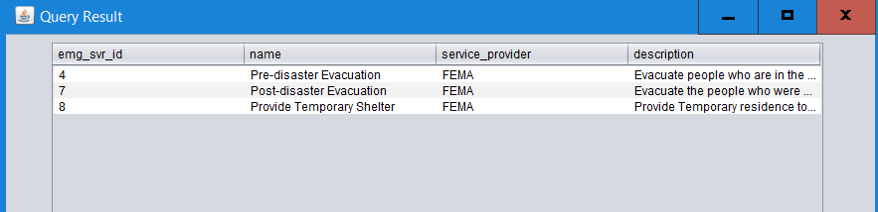

# **Project: Sprint 2 - Database design and implementation**

## ***REQUIREMENTS***

User Stories in decreasing order of priority

|  |  |
| --- | --- |
| **Story ID** | **Story description** |
| US1 | As a Database Administrator I want to add role with read/write access of a user with privileges. |
| US2 | As a User i should be able to login and logout of the application so that i can use the application. |
| US3 | As a Database Administrator I want to add name, type, city, state, country, start date, start time, end date, end time and intensity details of a disaster so that end users can use the information on demand. |
| US4 | As a Database Administrator I want to add name, service provider and description of emergency services provided for a disaster, so that end user can use the information on demand. |
| US5 | As a Database Administrator I want to add name and prevention possibility of adverse effects caused by a disaster, so that end user can use the information on demand. |
| US6 | As a user with the role of ‘Emergency Service Provider’, I want to add name, service provider and description of emergency services provided for a disaster, so that emergency services provided are tracked. |
| US7 | As a user with the role of ‘Adverse Effect Reporter’, I want to add name and prevention possibility of adverse effects caused by a disaster, so that end user can use the information on demand. |
| US8 | As a reporter I should be able to give name of a disaster as input and view details of that disaster so that I can report it to the government/authorities. |
| US9 | As a reporter I should be able to give city,state and country as input and view details of the disaster affecting that place so that I can report it to the government/authorities. |
| US10 | As a reporter I should be able to enter name of disaster and view details of emergency services provided for that disaster, so that I can report to the government/authorities. |
| US11 | As a reporter I should be able to enter name of disaster and view adverse effects of that disaster, so that I can report to the government/authorities |
| US12 | As a Database Administrator I want to add name, address, ssn, emergency contact and type of injury about the people who are injured during the disaster, so that end user can use the information on demand |
| US13 | As a Database Administrator I want to add name, address, ssn, emergency contact , death date and type of fatality about the people who lost their life during the disaster, so that end user can use the information on demand |
| US14 | As a user with the role of ‘Disaster Casualty Reporter’ I want to add name, address, ssn, emergency contact, type of injury about the people who are injured during the disaster, so that end user can use the information on demand |
| US15 | As a user with the role of ‘Disaster Casualty Reporter’ I want to add name, address, ssn, emergency contact, type of fatality, death date of people who lost their life during the disaster, so that end user can use the information on demand |
| US16 | As a reporter I want to enter disaster name and view details of people injured during the disaster so that I can report to the government/authorities |
| US17 | As a reporter I want to enter disaster name and view details of people died during the disaster so that I can report to the government/authorities |
| US18 | As a Database Administrator I want to add type of health-care management services provided (e.g. environmental health control, nutrition management, mental health control etc.) during the disaster, so that end user can use the information on demand |
| US19 | As a Medical Analyst I want to update type of health-care management services provided (e.g. environmental health control, nutrition management, mental health control etc.) during the disaster, so that I can use the information for analysis |
| US20 | As a Reporter, I want to enter disaster name and view health-care management services provided during a disaster so that I can report to the authorities/government. |
| US21 | As a Funding Analyst i want to update details of funding for disaster so that reporter can use the information. |
| US22 | As a Database Administrator I want to update insurance claimed so that reporter can use the information. |
| US23 | As a reporter I want to view insurance claimed, so that I can report to the government/authorities. |
| US24 | As a Insurance Analyst i want to update claimed insurance details so that reporter can use the information. |
| US25 | As a Database Administrator I want to update the funding for the disaster, so that reporter can use the information |
| US26 | As a reporter I want to view funding for disaster, so that I can report to the government/authorities. |

## 

## 

## ***CONCEPTUAL DESIGN***

Entity: **Disaster**

Attributes:

name

type

place [composite]

city,

state,

country

start_date

start_time

intensity

end_date

end_time

Primary key Justification: Every disaster will have a unique name. so combination of disaster name and place can uniquely identify each and every disaster in the system. Intensity will be defined with respect to disaster type on the respective scale like (Earthquake will be measured in Richter scale, Hurricane will be measured in Saffir-Simpson scale and Volcano will be measured in Volcanic Explosivity Index).

Entity: **EmergencyService**

Attributes:

name

services_provider

description

Primary key justification : Every service provided by a service provider will have a unique name. Combination of service_provider and name can uniquely identify emergency services in the system.

Entity: **AdverseEffect**

Attributes:

name

preventive

Primary key justification : From the name of adverse effect we can uniquely identify AdverseEffect.Preventive attribute will define whether the adverse effect was preventive (food outage, water outage) or non preventive (acid rain, landslide).

Entity: **User**

Attributes:

user_name

password

Primary key justification : Each user will have unique user_name, so from use_name we can uniquely identify the User.

Entity: **Role**

Attributes:

role_name

privilege

Primary key Justification : As every role will have a unique role_name, role_name can uniquely identify roles.

Entity: **Fatality**

Attributes:

name [composite]

ssn

address [composite]

apartment number,

street number,

country,

zip_code

emergency_contact

cause_of_death

date_of_death

Primary key justification: Every person will have a unique ssn so that they can be uniquely identified.

Entity: **Injured**

Attributes:

name [composite]

ssn

address [composite]

apartment number,

street number,

country,

zip_code

emergency_contact

type_of_injury

Primary key justification: Every person will have a unique ssn so that they can be uniquely identified.

Entity: **HealthCareManagementService**

Attributes:

type_of_service

Primary key justification: Every row will have a unique type_of_service which is name of the service provided.

**Relationships:**

Relationship: **Disaster** leads to **AdverseEffect**

Cardinality:

Many to many

Participation:

**Disaster** has total participation

**AdversEffect** has partial participation

Note : Assuming every disaster has adverse effect.

Relationship: **EmergencyService** offered for **Disaster**

Cardinality:

Many to many

Participation:

**Disaster** has total participation

**EmergencyService** has partial participation

Note : Assuming every disaster requires emergency service.

Relationship: **User** has a **Role**

Cardinality:

Many to One

Participation:

**User** has total participation

**Role** has partial participation

Note : Every User will have only one role in the system.

Relationship: **Fatality** due to **Disaster**

Cardinality:

Many to One

Participation:

**Fatality** has total participation

**Disaster** has partial participation

Relationship: **Injured** due to **Disaster**

Cardinality:

Many to Many

Participation:

**Injured** has total participation

**Disaster** has partial participation

Relationship: **HealthCareManagementService** provided during **Disaster**

Cardinality:

Many to Many

Participation:

**HealthCareManagementService** has partial participation

**Disaster** has partial participation

## ***LOGICAL DESIGN***

Table: **Disaster**

Columns:

disaster_id

name

type_id[foreign key; references **type_id** of **DisasterType** table]

intensity_id[foreign key; references **intensity_id** of **DisasterIntensity** table]

city

country

start_date

start_time

end_date

end_time

Primary Key Justification: From the disaster_id we can uniquely identify the disaster.

Foreign Key approach Justification: Foreign Key approach has been followed here as each disaster_id is related to only one type_id of DisasterType. Foreign key approach has been followed for adding intensity_id column which refers to DisasterIntensitytable as each disaster will refer to any one column value of the DisasterIntensitytable.

Normalization form: The above table is in the 2nd normal form since the attribute city is functionally dependent on the country. We are leaving the table in 2nd normal since the new table for the city and country will add a new level of abstraction which is not required at this stage in our database.

Table: **DisasterIntensity**

Columns:

intensity_id

intensity_range

Primary Key Justification: Every DisasterIntensitycan be uniquely identified from the intensity_id. Seperate table has been created to relate each disaster to a intensity type.

Normalization form: The above table is in 4th normal form.

Table: **DisasterType**

Columns:

type_id

disaster_type

Primary Key Justification : We created separate table for disaster type. We are covering 5 types of disasters which are Earthquake, Tsunami, Volcano, Nuclear-Explosion and Hurricane.

Normalization form: The above table is in 4th normal form.

Table: **Fatality**

Columns:

ssn

first_name

last_name

address_line_1

city

zip_code

country

emergency_contact

date_of_death

death_type_id[foreign Key:references **death_type_id** of **DeathType**]

disaster_id [foreign key; references **disaster_id** of **Disaster** table]

Primary Key Justification: Each fatalitycan be uniquely identified with the help of ssn.

Foreign Key approach Justification: Foreign key approach has been followed here for death_type_id as each fatality corresponds to one death_type_id in DeathType**.** Foreign key approach has been followed here for disaster_id as each fatality corresponds to a single disaster in Disaster.

Normalization form: The above table is in 2nd Normal Form since the address_line_1, city, zip_code and country are interdependent on each other and separating this columns to a different table will not be relevant for the database need.

Table: **DeathType**

Columns:

death_type_id

cause_of_death

Primary Key Justification: EveryDeathType rowwill have a unique death_type_id.

Normalization form: The above table is in 4th Normal Form.

Table: **Injured**

Attributes:

ssn

first_name

last_name

address_line_1

city

country

zip_code

emergency_contact

Primary Key Justification: Injured row can be uniquely identified with ssn.

Normalization form: The above table is in 2nd Normal Form since the address_line_1, city, zip_code and country are interdependent on each other and separating this columns to a different table will not be relevant for the database need.

Table: **InjuredType**

Columns:

injury_type_id

type_of_injury

Primary Key Justification: Every **InjuredType** row will have a unique injury_type_id.

Normalization: The above table is in 4th normal form.

Table: **HealthCareManagementService**

Columns:

service_id

type_of_service

Primary Key Justification: Every service provided will have a unique service_id.

Normalization: The above table is in 4th normal form.

Table: **EmergencyService**

Columns:

emg_svr_id

name

service_provider

description

Primary Key Justification : From emg_svr_id we can uniquely identify the **EmergencyService**.

Normalization: The above table is in 4th normal form.

Table : **AdverseEffect**

Columns:

adverse_id

name

preventive

Justification: From adverse_id we can uniquely identify the **AdverseEffect**.

Normalization:The above table is in 4th normal form.

Table: **Role**

Columns:

role_id

role_name

privilege

Justification:From role_id we can uniquely identify the **Role**.

Normalization: The above table is in 4th normal form.

Table: **User**

Columns:

user_name

password

role_id [foreign key; references **role_id** of **Role** table]

Justification : As each **User** will have specific role_id of role table, foreign key approach has been followed. Every **User** will have unique user_name.

Normalization: The above table is in 4th normal form.

Table : **DisAdvEff**

Columns:

disaster_id [foreign key; references **disaster_id** of **Disaster** table]

adverse_id [foreign key; references **adverse_id** of **AdverseEffect** table]

Foreign Key Justification : As a disaster_id can be linked to multiple adverse_id and a adverse_id can be linked to multiple disaster_id, cross reference approach has been followed to establish relationship.

Normalization:The above table is in 4th normal form.

Table : **DisEmgSvr**

Columns:

disaster_id [foreign key; references **disaster_id** of **Disaster** table]

emg_svr_id [foreign key; references **emg_svr_id** of **EmergencyService** table]

pre

post

Justification : As a disaster_id can be linked to multiple emg_svr_id and a emg_svr_id can be linked to multiple disaster_id, cross reference approach has been followed to establish relationship.

Normalization: The above table is in 4th normal form.

Table: **DisasterInjured**

Columns:

disaster_id [foreign key; references **disaster_id** of **Disaster** table]

ssn[foreign key; references **ssn** of **Injured** table]

injury_type_id[foreign key; references **injury_type_id** of **InjuryType** table]

Foreign Key Justification: Cross reference approach has been followed to establish many to many relationship betweenInjuredand DisasterInjuredrelationship. Here it is assumed that a person can be affected in multiple disasters.

Normalization: The above table is in 4th normal form.

Table: **HealthCareMngmtSvcDis**

Columns:

disaster_id [foreign key; references **disaster_id** of **Disaster** table]

service_id [foreign key; references **service_id** of **HealthCareManagementService** table]

Foreign key Justification: cross reference approach has been followed to establish many to many relationship between Disasterand HealthCareManagementService

Normalization: The above table is in 4th normal form.

**Query and Screenshots:**

Query 1

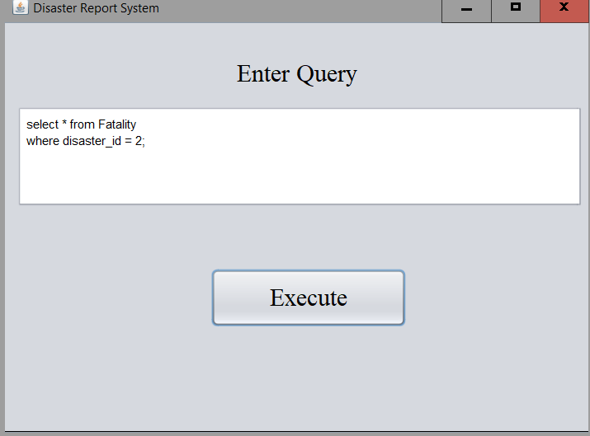

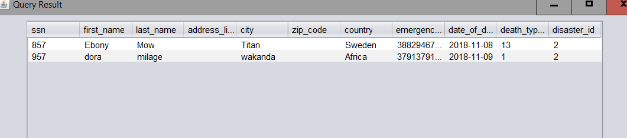

Query 2:

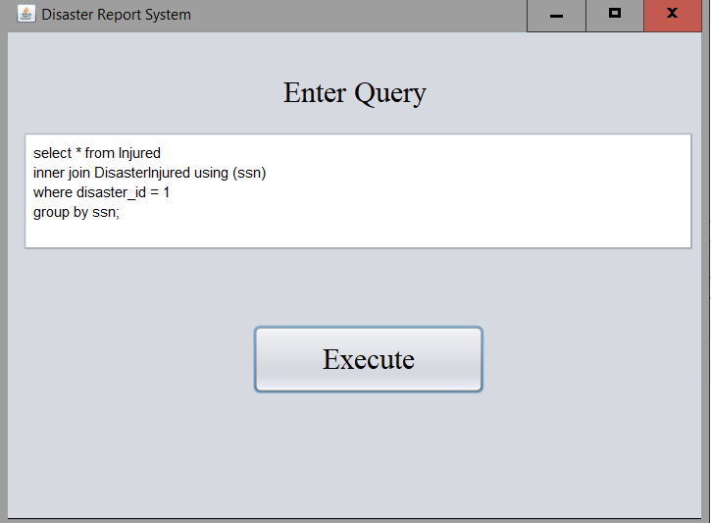

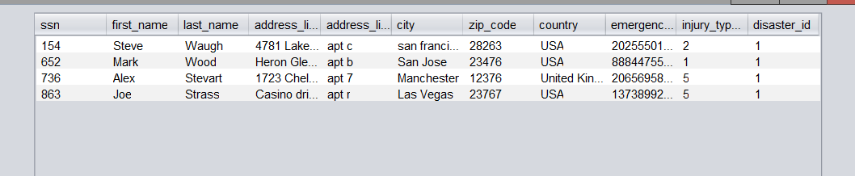

Query 3:

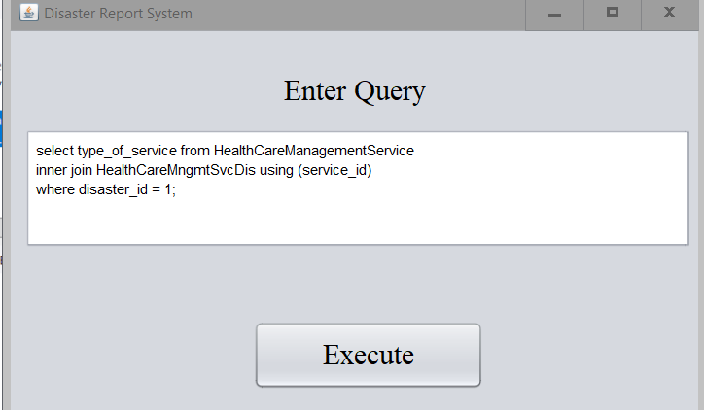

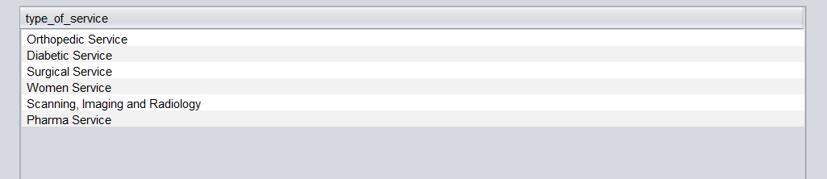

# **Project: Sprint 3 - Database design and implementation**

## ***REQUIREMENTS***

User Stories in decreasing order of priority

|  |  |
| --- | --- |
| **Story ID** | **Story description** |
| US1 | As a Database Administrator I want to add role with read/write access of a user with privileges. |
| US2 | As a User i should be able to login and logout of the application so that i can use the application. |
| US3 | As a Database Administrator I want to add name, type, city, state, country, start date, start time, end date, end time and intensity details of a disaster so that end users can use the information on demand. |
| US4 | As a Database Administrator I want to add name, service provider and description of emergency services provided for a disaster, so that end user can use the information on demand. |
| US5 | As a Database Administrator I want to add name and prevention possibility of adverse effects caused by a disaster, so that end user can use the information on demand. |
| US6 | As a user with the role of ‘Emergency Service Provider’, I want to add name, service provider and description of emergency services provided for a disaster, so that emergency services provided are tracked. |
| US7 | As a user with the role of ‘Adverse Effect Reporter’, I want to add name and prevention possibility of adverse effects caused by a disaster, so that end user can use the information on demand. |
| US8 | As a reporter I should be able to give name of a disaster as input and view details of that disaster so that I can report it to the government/authorities. |
| US9 | As a reporter I should be able to give city,state and country as input and view details of the disaster affecting that place so that I can report it to the government/authorities. |
| US10 | As a reporter I should be able to enter name of disaster and view details of emergency services provided for that disaster, so that I can report to the government/authorities. |
| US11 | As a reporter I should be able to enter name of disaster and view adverse effects of that disaster, so that I can report to the government/authorities |
| US12 | As a Database Administrator I want to add name, address, ssn, emergency contact and type of injury about the people who are injured during the disaster, so that end user can use the information on demand |
| US13 | As a Database Administrator I want to add name, address, ssn, emergency contact , death date and type of fatality about the people who lost their life during the disaster, so that end user can use the information on demand |
| US14 | As a user with the role of ‘Disaster Casualty Reporter’ I want to add name, address, ssn, emergency contact, type of injury about the people who are injured during the disaster, so that end user can use the information on demand |
| US15 | As a user with the role of ‘Disaster Casualty Reporter’ I want to add name, address, ssn, emergency contact, type of fatality, death date of people who lost their life during the disaster, so that end user can use the information on demand |
| US16 | As a reporter I want to enter disaster name and view details of people injured during the disaster so that I can report to the government/authorities |
| US17 | As a reporter I want to enter disaster name and view details of people died during the disaster so that I can report to the government/authorities |
| US18 | As a Database Administrator I want to add type of health-care management services provided (e.g. environmental health control, nutrition management, mental health control etc.) during the disaster, so that end user can use the information on demand |
| US19 | As a Medical Analyst I want to update type of health-care management services provided (e.g. environmental health control, nutrition management, mental health control etc.) during the disaster, so that I can use the information for analysis |
| US20 | As a Reporter, I want to enter disaster name and view health-care management services provided during a disaster so that I can report to the authorities/government. |
| US21 | As a Funding Analyst, I want to update details of funding like amount and funder name for disaster so that information can be used for analysis. |
| US22 | As a Database Administrator, I want to update details of funding like amount and funder name for disaster, so that end user can use the information |
| US23 | As a reporter I want to view funding amount for disaster, so that I can report to the government/authorities. |

## 

## ***CONCEPTUAL DESIGN***

Entity: **Disaster**

Attributes:

name

type

place [composite]

city,

state,

country

start_date

start_time

intensity

end_date

end_time

Primary key Justification: Every disaster will have a unique name. so combination of disaster name and place can uniquely identify each and every disaster in the system. Intensity will be defined with respect to disaster type on the respective scale like (Earthquake will be measured in Richter scale, Hurricane will be measured in Saffir-Simpson scale and Volcano will be measured in Volcanic Explosivity Index).

Entity: **EmergencyService**

Attributes:

name

services_provider

description

Primary key justification : Every service provided by a service provider will have a unique name. Combination of service_provider and name can uniquely identify emergency services in the system.

Entity: **AdverseEffect**

Attributes:

name

preventive

Primary key justification : From the name of adverse effect we can uniquely identify AdverseEffect.Preventive attribute will define whether the adverse effect was preventive (food outage, water outage) or non preventive (acid rain, landslide).

Entity: **User**

Attributes:

user_name

password

Primary key justification : Each user will have unique user_name, so from use_name we can uniquely identify the User.

Entity: **Role**

Attributes:

role_name

privilege

Primary key Justification : As every role will have a unique role_name, role_name can uniquely identify roles.

Entity: **Fatality**

Attributes:

name [composite]

ssn

address [composite]

apartment number,

street number,

country,

zip_code

emergency_contact

cause_of_death

date_of_death

Primary key justification: Every person will have a unique ssn so that they can be uniquely identified.

Entity: **Injured**

Attributes:

name [composite]

ssn

address [composite]

apartment number,

street number,

country,

zip_code

emergency_contact

type_of_injury

Primary key justification: Every person will have a unique ssn so that they can be uniquely identified.

Entity: **HealthCareManagementService**

Attributes:

type_of_service

Primary key justification: Every row will have a unique type_of_service which is name of the service provided.

Entity: **Funding**

Attributes:

funder_name

amount(in USD)

Primary key justification: Every row will have a unique funder_name

**Relationships:**

Relationship: **Disaster** leads to **AdverseEffect**

Cardinality:

Many to many

Participation:

**Disaster** has total participation

**AdversEffect** has partial participation

Note : Assuming every disaster has adverse effect.

Relationship: **EmergencyService** offered for **Disaster**

Cardinality:

Many to many

Participation:

**Disaster** has total participation

**EmergencyService** has partial participation

Note : Assuming every disaster requires emergency service.

Relationship: **User** has a **Role**

Cardinality:

Many to One

Participation:

**User** has total participation

**Role** has partial participation

Note : Every User will have only one role in the system.

Relationship: **Fatality** due to **Disaster**

Cardinality:

Many to One

Participation:

**Fatality** has total participation

**Disaster** has partial participation

Relationship: **Injured** due to **Disaster**

Cardinality:

Many to Many

Participation:

**Injured** has total participation

**Disaster** has partial participation

Relationship: **HealthCareManagementService** provided during **Disaster**

Cardinality:

Many to Many

Participation:

**HealthCareManagementService** has partial participation

**Disaster** has partial participation

Relationship: **Funding** provided for **Disaster**

Cardinality:

Many to Many

Participation:

**Funding** has total participation

**Disaster** has partial participation

## ***LOGICAL DESIGN***

Table: **Disaster**

Columns:

disaster_id

name

type_id[foreign key; references **type_id** of **DisasterType** table]

intensity_id[foreign key; references **intensity_id** of **DisasterIntensity** table]

city

country

start_date

start_time

end_date

end_time

Primary Key Justification: From the disaster_id we can uniquely identify the disaster.

Foreign Key approach Justification: Foreign Key approach has been followed here as each disaster_id is related to only one type_id of DisasterType. Foreign key approach has been followed for adding intensity_id column which refers to DisasterIntensitytable as each disaster will refer to any one column value of the DisasterIntensitytable.

Normalization form: The above table is in the 2nd normal form since the attribute city is functionally dependent on the country. We are leaving the table in 2nd normal since the new table for the city and country will add a new level of abstraction which is not required at this stage in our database.

Indexes:

Index: clustered

Columns: disaster_id

Justification: As disaster_id is a primary key, database by default considers it as a clustered index.

Index: non clustered

Columns: type_id

Justification: As type_id is a foreign key, database by default considers it as a non clustered index.

Index: non clustered

Columns: intensity_id

Justification: As intensity_id is a foreign key, database by default considers it as a non clustered index.

Index: non clustered

Columns: name

Justification: In most of the queries the search will be based on the name of the disaster, so name is considered as non clustered index.

Table: **DisasterIntensity**

Columns:

intensity_id

intensity_range

Primary Key Justification: Every DisasterIntensitycan be uniquely identified from the intensity_id. Seperate table has been created to relate each disaster to a intensity type.

Indexes:

Index: clustered

Columns: intensity_id

Justification: As intensity_id is a primary key, database by default considers it as a clustered index.

Normalization form: The above table is in 4th normal form.

Table: **DisasterType**

Columns:

type_id

disaster_type

Primary Key Justification : We created separate table for disaster type. We are covering 5 types of disasters which are Earthquake, Tsunami, Volcano, Nuclear-Explosion and Hurricane.

Normalization form: The above table is in 4th normal form.

Indexes:

Index: clustered

Columns: type_id

Justification: As type_id is a primary key, database by default considers it as a clustered index.

Index: non clustered

Columns: disaster_type

Justification: In most of the queries the search will be based on the disaster_type of the disaster, so disaster_type is considered as non clustered index.

Table: **Fatality**

Columns:

ssn

first_name

last_name

address_line_1

city

zip_code

country

emergency_contact

date_of_death

death_type_id[foreign Key:references **death_type_id** of **DeathType**]

disaster_id [foreign key; references **disaster_id** of **Disaster** table]

Primary Key Justification: Each fatalitycan be uniquely identified with the help of ssn.

Foreign Key approach Justification: Foreign key approach has been followed here for death_type_id as each fatality corresponds to one death_type_id in DeathType**.** Foreign key approach has been followed here for disaster_id as each fatality corresponds to a single disaster in Disaster.

Normalization form: The above table is in 2nd Normal Form since the address_line_1, city, zip_code and country are interdependent on each other and separating this columns to a different table will not be relevant for the database need.

Indexes:

Index: clustered

Columns: ssn

Justification: As ssn is a primary key, database by default considers it as a clustered index.

Index: non clustered

Columns: death_type_id

Justification: As death_type_id is a foreign key, database by default considers it as a non clustered index.

Index: non clustered

Columns: disaster_id

Justification: As disaster_id is a foreign key, database by default considers it as a non clustered index.

Table: **DeathType**

Columns:

death_type_id

cause_of_death

Primary Key Justification: EveryDeathType rowwill have a unique death_type_id.

Normalization form: The above table is in 4th Normal Form.

Indexes:

Index: clustered

Columns: death_type_id

Justification: As death_type_id is a primary key, database by default considers it as a clustered index.

Table: **Injured**

Attributes:

ssn

first_name

last_name

address_line_1

city

country

zip_code

emergency_contact

Primary Key Justification: Injured row can be uniquely identified with ssn.

Normalization form: The above table is in 2nd Normal Form since the address_line_1, city, zip_code and country are interdependent on each other and separating this columns to a different table will not be relevant for the database need.

Indexes:

Index: clustered

Columns: ssn

Justification: As ssn is a primary key, database by default considers it as a clustered index.

Table: **InjuredType**

Columns:

injury_type_id

type_of_injury

Primary Key Justification: Every **InjuredType** row will have a unique injury_type_id.

Normalization: The above table is in 4th normal form.

Indexes:

Index: clustered

Columns: injury_type_id

Justification: As injury_type_idis a primary key, database by default considers it as a clustered index.

Index: non clustered

Columns: type_of_injury

Justification: In most of the queries the search will be based on the type_of_injury , so type_of_injury is considered as non clustered index.

Table: **HealthCareManagementService**

Columns:

service_id

type_of_service

Primary Key Justification: Every service provided will have a unique service_id.

Normalization: The above table is in 4th normal form.

Indexes:

Index: clustered

Columns: service_id

Justification: As service_id is a primary key, database by default considers it as a clustered index.

Index: non clustered

Columns: type_of_service

Justification: In most of the queries the search will be based on the type_of_service, so type_of_service is considered as non clustered index.

Table: **EmergencyService**

Columns:

emg_svr_id

name

service_provider

description

Primary Key Justification : From emg_svr_id we can uniquely identify the **EmergencyService**.

Normalization: The above table is in 4th normal form.

Indexes:

Index: clustered

Columns: emg_svr_id

Justification: As emg_svr_id is a primary key, database by default considers it as a clustered index.

Index: non clustered

Columns: name

Justification: In most of the queries the search will be based on the name of the EmergencyService, so name is considered as non clustered index.

Table : **AdverseEffect**

Columns:

adverse_id

name

preventive

Justification: From adverse_id we can uniquely identify the **AdverseEffect**.

Normalization:The above table is in 4th normal form.

Indexes:

Index: clustered

Columns: adverse_id

Justification: As adverse_id is a primary key, database by default considers it as a clustered index.

Table: **Role**

Columns:

role_id

role_name

privilege

Justification:From role_id we can uniquely identify the **Role**.

Normalization: The above table is in 4th normal form.

Indexes:

Index: clustered

Columns: role_id

Justification: As role_id is a primary key, database by default considers it as a clustered index.

Index: non clustered

Columns: role_name

Justification: In most of the queries the search will be based on the role_name, so role_name is considered as non clustered index.

Table: **User**

Columns:

user_name

password

role_id [foreign key; references **role_id** of **Role** table]

Justification : As each **User** will have specific role_id of role table, foreign key approach has been followed. Every **User** will have unique user_name.

Normalization: The above table is in 4th normal form

Indexes:

Index: clustered

Columns: user_name

Justification: As user_name is a primary key, database by default considers it as a clustered index.

Index: non clustered

Columns: role_id

Justification: As role_id is a foreign key, database by default considers it as a non clustered index.

Table : **DisAdvEff**

Columns:

disaster_id [foreign key; references **disaster_id** of **Disaster** table]

adverse_id [foreign key; references **adverse_id** of **AdverseEffect** table]

Foreign Key Justification : As a disaster_id can be linked to multiple adverse_id and a adverse_id can be linked to multiple disaster_id, cross reference approach has been followed to establish relationship.

Normalization:The above table is in 4th normal form.

Indexes:

Index: clustered

Columns: disaster_id,adverse_id

Justification: As disaster_id, adverse_id is a primary key, database by default will create **clustered index** that consists of **two columns**.

Table : **DisEmgSvr**

Columns:

disaster_id [foreign key; references **disaster_id** of **Disaster** table]

emg_svr_id [foreign key; references **emg_svr_id** of **EmergencyService** table]

pre

post

Justification : As a disaster_id can be linked to multiple emg_svr_id and a emg_svr_id can be linked to multiple disaster_id, cross reference approach has been followed to establish relationship.

Normalization: The above table is in 4th normal form.

Indexes:

Index: clustered

Columns: disaster_id, emg_svr_id

Justification: As disaster_id, emg_svr_id is a primary key, database by default considers it as a clustered index.

Index: non clustered

Columns: disaster_id

Justification: As disaster_id is a foreign key, database by default considers it as a non clustered index.

Index: non clustered

Columns: emg_svr_id

Justification: As emg_svr_id is a foreign key, database by default considers it as a non clustered index.

Table: **DisasterInjured**

Columns:

disaster_id [foreign key; references **disaster_id** of **Disaster** table]

ssn[foreign key; references **ssn** of **Injured** table]

injury_type_id[foreign key; references **injury_type_id** of **InjuryType** table]

Foreign Key Justification: Cross reference approach has been followed to establish many to many relationship betweenInjuredand DisasterInjuredrelationship. Here it is assumed that a person can be affected in multiple disasters.

Normalization: The above table is in 4th normal form.

Indexes:

Index: clustered

Columns: disaster_id, ssn, injury_type_id

Justification: As disaster_id, ssn, injury_type_id is a primary key, database by default considers it as a clustered index.

Index: non-clustered

Columns: injury_type_id

Justification: As injury_type_id is a foreign key, database by default considers it as a non clustered index.

Index: non-clustered

Columns: disaster_id

Justification: As disaster_id is a foreign key, database by default considers it as a non clustered index.

Table: **HealthCareMngmtSvcDis**

Columns:

disaster_id [foreign key; references **disaster_id** of **Disaster** table]

service_id [foreign key; references **service_id** of **HealthCareManagementService** table]

num_served

Foreign key Justification: cross reference approach has been followed to establish many to many relationship between Disasterand HealthCareManagementService.

Note: num_served is the number of people who were served with particular service during the disaster

Normalization: The above table is in 4th normal form.

Indexes:

Index: clustered

Columns: disaster_id, service_id

Justification: As disaster_id, service_id is a primary key, database by default considers it as a clustered index.

Index: non clustered

Columns: service_id

Justification: As service_id is a foreign key, database by default considers it as a non clustered index.

Table: **Funding**

Columns:

disaster_id [foreign key; references **disaster_id** of **Disaster** table]

funder_id [foreign key; references **funder_id** of **FunderDetail** table]

amount(in USD)

Foreign key Justification: cross reference approach has been followed to establish many to many relationship between Disasterand Funding.

Normalization: The above table is in 4th normal form.

Indexes:

Index: clustered

Columns: disaster_id, funder_id

Justification: As disaster_id, funder_id is a primary key, database by default considers it as a clustered index.

Index: non clustered

Columns: funder_id

Justification: As funder_id is a foreign key, database by default considers it as a non clustered index.

Table: **FunderDetail**

Columns:

funder_id

funder_org_name

Primary Key Justification: From the funder_id we can uniquely identify the every funder/organization.

Normalization: The above table is in 4th normal form.

Indexes:

Index: clustered

Columns: funder_id

Justification: As funder_id is a primary key, database by default considers it as a clustered index.

Index: non clustered

Columns: funder_org_name

Justification: In most of the queries the search will be based on the funder_org_name, so funder_org_name is considered as non clustered index.

**Views and Stored Programs**

**Views**

View: **DisasterAdverseEffects**

Goal: name of the disaster, type of disaster and all the adverse effects of that disaster(comma separated) is reported for all the disasters in the system.

A Reporter or a Adverse Effect Reporter will be able to view the multiple adverse effects of all disasters in one table without need for writing complex queries

View: **DisasterDeathCount**

Goal: name of the disaster, type of disaster and death count for a disaster is reported for all the disasters in the system.

A Disaster Casualty Reporter can use this view to see the total count of fatality for each disaster without having to write the query every time.

View: **DisasterInjuredCount**

Goal: name of the disaster, type of disaster and Injured count for a disaster is reported for all the disasters in the system.

A Disaster Casualty Reporter can use this view to see the total count of injured people for each disaster without having to write the query every time.

View: **DisasterFundingDetails**

Goal: name of the disaster, type of funding and amount given as funds for a disaster is reported for all the disasters in the system.

A Funding Analyst can use this view to see the funding provided by each funder for every disaster without having to write the query every time.

View: **EmergencyServiceDetails**

Goal: name of the disaster, name of service provided, service provider and type of service provided for a disaster is reported for all the disasters in the system.

A Emergency Service Provider can use this view to see the information regarding emergency services provided for every disaster without having to write the query every time.

View: **HealthCareServicesForDisaster**

Goal: name of the disaster, type of disaster,type of service provided and total count of people who got served for a disaster is reported for all the disasters in the system.

A Medical Analyst can use this view to see the overall medical services provided and total count of people who got served per diasaster for all disasters in the system.

View: **userRole**

Goal: All the users in the system with their roles and privileges is reported in the system

A Database Administrator can view all the available users, roles and their privileges using this view

**Procedures**

Stored Procedure: **DisasterSpecificAdverseEffects**

Parameters: in name_input varchar(255)

Goal: This stored procedure takes disaster name as the input and gives adverse effect specific information of that particular disaster

Stored Procedure: **DisasterSpecificFatalityInfo**

Parameters: in name_input varchar(255)

Goal: This stored procedure takes disaster name as the input and gives information of the people and also thier cause of death and date of death

Stored Procedure: **DisasterSpecificInjuredInfo**

Parameters: in name_input varchar(255)

Goal: This stored procedure takes disaster name as the input and gives information of the injured people and also injuries sustained by them in that disaster

Stored Procedure: **DisasterTypeSpecificHealthCareManagementServices**

Parameters: in type_input varchar(255),in service_input varchar(255)

Goal: This stored procedure takes disaster type and service type as the input and gives information of number of people who opted that particular service type for all the disasters with given disaster type

Stored Procedure: **DisasterSpecificFundingInfo**

Parameters: in name_input varchar(255)

Goal: This stored procedure takes disaster name as the input and gives the information about the funding provided by the funding organisations to a particular disaster

Stored Procedure: **DisasterSpecificEmergencyServices**

Parameters: in name_input varchar(255)

Goal: This stored procedure takes disaster name as the input and gives information of services provided(for the disaster) by every department